## **Project By: Zohaib Saadat**

## **Submitted to: Sir Farhan Khalid & Sir Ibad Ur Rahman**

**Course: ADC (EE3003)**

## **Project Overview**

In this research, we want to simulate and analyze a communication system using Single Sideband Frequency Division Multiplexing (SSB-FDM). Three separate audio messages are recorded as part of the system, and the signals are then multiplexed, modulated, and noise-boosted. To retrieve the original messages, the received signals are subsequently subjected to demodulation, demultiplexing, and Single Sideband Amplitude Modulation (SSB-AM) demodulation. The effects of noise at various signal-to-noise ratio (SNR) levels on the demodulated signals are investigated via audio playback and visuals, such as graphs and plots of the magnitude spectra of each signal at the transmitter side in comparison with the receiver’s demultiplexed and demodulated signal.

**PROJECT CODE:**

% Recording, Playing and Write Audio File

clc;close all;clear all;

warning off

recObj = audiorecorder;% audiorecorder creates an 8000 Hz, 8-bit, 1 channel audiorecorder object.

% audiorecorder(Fs, NBITS, NCHANS) creates an audiorecorder object with

% sample rate Fs in Hertz, number of bits NBITS, and number of channels NCHANS.

% Common sample rates are 8000, 11025, 22050, 44100, 48000, and 96000 Hz.

% The number of bits must be 8, 16, or 24. The number of channels must

% be 1 or 2 (mono or stereo).

% audiorecorder(Fs, NBITS, NCHANS, ID) creates an audiorecorder object using

% audio device identifier ID for input. If ID equals -1 the default input

% device will be used.

recObj2 = audiorecorder;

recObj3 = audiorecorder;

Fs = 10000 ; % Sampling frequency in hertz8000, 11025, 22050, 44100, 48000, and 96000 Hz.

nBits = 16 ;% 8, 16, or 24

nChannels = 1 ; %Number of channels--2 options--1 (mono) or 2 (stereo)

ID = -1; % default audio input device like Microphone

recObj = audiorecorder(Fs,nBits,nChannels,ID);

recObj2 = audiorecorder(Fs,nBits,nChannels,ID);

recObj3 = audiorecorder(Fs,nBits,nChannels,ID);

disp('Start speaking.')

recordblocking(recObj,5);

disp('End of Recording.');

%play(recObj);

mySpeech = getaudiodata(recObj); % returns the recorded audio data as a double array

%Write audio file

audiowrite('m1.wav',mySpeech,Fs);

pause(1)

disp('Start speaking.')

recordblocking(recObj2,5);

% recordblocking(OBJ, T) records for length of time, T, in seconds;

% does not return until recording is finished.

disp('End of Recording.');

%play(recObj2);

mySpeech = getaudiodata(recObj2); % returns the recorded audio data as a double array

% getaudiodata(OBJ, DATATYPE) returns the recorded audio data in

% the data type as requested in string DATATYPE. Valid data types

% are 'double', 'single', 'int16', 'uint8', and 'int8'.

%Write audio file

audiowrite('m2.wav',mySpeech,Fs);

pause(1)

disp('Start speaking.')

recordblocking(recObj3,5);

% recordblocking(OBJ, T) records for length of time, T, in seconds;

% does not return until recording is finished.

disp('End of Recording.');

%play(recObj3); %PLAYS AUDIO BACK TO YOU

mySpeech = getaudiodata(recObj3); % returns the recorded audio data as a double array

% getaudiodata(OBJ, DATATYPE) returns the recorded audio data in

% the data type as requested in string DATATYPE. Valid data types

% are 'double', 'single', 'int16', 'uint8', and 'int8'.

%Write audio file

audiowrite('m3.wav',mySpeech,Fs);

%modulation stage:

%%%% Reading and Plotting Audio Signal with Noise %%%%%%%%%%%%%%%%%%%%%%%%%

clc;clear all; close all

[signal_orignal,Fs] = audioread('m1.wav');

samples=24000; %i used 24000 instead of 48K samples as my computer would crash due to stack overflow at 48K

%noisy_signal = signal_orignal(1:samples)+0.05*randn(1,samples)';

signal1 = signal_orignal(1:samples);

f = -Fs/2:Fs/samples:Fs/2-(Fs/samples);

[signal_orignal2,Fs] = audioread('m2.wav');

%noisy_signal = signal_orignal(1:samples)+0.05*randn(1,samples)';

signal2 = signal_orignal2(1:samples);

[signal_orignal3,Fs] = audioread('m3.wav');

%noisy_signal = signal_orignal(1:samples)+0.05*randn(1,samples)';

signal3 = signal_orignal(1:samples);

figure

subplot (2,2,1)

plot(f,abs(fftshift(fft(signal1)))) % FFT (not normalized)

title('Magnitude Spectrum of Signal 1 m1'), grid

sound(signal1,Fs)

subplot (2,2,2)

plot(f,abs(fftshift(fft(signal2)))) % FFT (not normalized)

title('Magnitude Spectrum of Signal 2 m2'), grid

sound(signal2,Fs)

subplot (2,2,3)

plot(f,abs(fftshift(fft(signal3)))) % FFT (not normalized)

title('Magnitude Spectrum of Signal 3 m3'), grid

sound(signal3,Fs)

%part 2

N = size(signal1,1); % Row Length Of ‘y’

Ts = 1/Fs; % Sampling Interval (seconds)

t = linspace(0, 1, N)'*Ts; % Time Column Vector

%%%%%% Implementing Low Pass Filter %%%%%%%%%%%%%%

f_cut = 3000; % LPF cutoff frequency in Hz

ord = 4; % LPF filter order

[b,a]=butter(ord,f_cut/(Fs/2));

% [b,a]=butter(4,20/500);

env = filter(b,a,signal1);

env2 = filter(b,a,signal2);

env3 = filter(b,a,signal3);

y = env - mean(env)

y2 = env2 - mean(env2)

y3 = env3 - mean(env3)

Zk = fft(y)/N; % Computing fft for signal1

Z = fftshift(abs(Zk));

Zk2 = fft(y2)/N; % Computing fft for signal2

Z2 = fftshift(abs(Zk2));

Zk3 = fft(y3)/N; % Computing fft for signal3

Z3 = fftshift(abs(Zk3));

figure

subplot(241)

plot(t,y,'linewidth',1);

% ylim([-1 1])

title('TASK PART 2: signal 1 in time domain');

grid on;

subplot(242)

fz = -Fs/2:Fs/length(Z):Fs/2-(Fs/length(Z));

stem(fz,Z,'linewidth',1);

% xlim([-20 20])

title('TASK PART 2: signal 1 in frequency domain');

grid on;

subplot(243)

plot(t,y2,'linewidth',1);

% ylim([-1 1])

title('TASK PART 2: signal 2 in time domain');

grid on;

subplot(244)

fz2 = -Fs/2:Fs/length(Z2):Fs/2-(Fs/length(Z2));

stem(fz2,Z2,'linewidth',1);

% xlim([-20 20])

title('TASK PART 2: signal 2 in freq domain');

grid on;

subplot(245)

plot(t,y3,'linewidth',1);

% ylim([-1 1])

title('TASK PART 2: signal 3 in time domain');

grid on;

subplot(246)

fz3 = -Fs/2:Fs/length(Z3):Fs/2-(Fs/length(Z3));

stem(fz3,Z3,'linewidth',1);

% xlim([-20 20])

title('TASK PART 2');

grid on;

%part 3:

% USSB AM modulation for each message with a 1 kHz guard band

Fc1 = 5000; % Carrier frequency for message 1 (5 kHz)

Fc2 = 9000; % Carrier frequency for message 2 (9 kHz)

Fc3 = 13000; % Carrier frequency for message 3 (13 kHz)

guard_band = 1e3; % Guard band (1 kHz)

% Modulate messages using USSB AM

modulated_signal1 = signal1 .* cos(2*pi*(Fc1 + guard_band/2)*t);

modulated_signal2 = signal2 .* cos(2*pi*(Fc2 + guard_band/2)*t);

modulated_signal3 = signal3 .* cos(2*pi*(Fc3 + guard_band/2)*t);

% Combine modulated signals with guard band

combined_signal = modulated_signal1 + modulated_signal2 + modulated_signal3;

% SSB-FDM modulation using USSB AM

Fc_final = 400000; % Carrier frequency for final modulation (400 kHz)

ssb_fdm_signal = combined_signal .* cos(2*pi*(Fc_final)*t);

% Plot the original messages, modulated signals, and final SSB-FDM signal

figure;

subplot(4,1,1);

plot(t, signal1);

title('Message 1');

xlabel('Time (s)');

ylabel('Amplitude');

subplot(4,1,2);

plot(t, signal2);

title('Message 2');

xlabel('Time (s)');

ylabel('Amplitude');

subplot(4,1,3);

plot(t, signal3);

title('Message 3');

xlabel('Time (s)');

ylabel('Amplitude');

subplot(4,1,4);

plot(t, ssb_fdm_signal);

title('SSB-FDM Signal');

xlabel('Time (s)');

ylabel('Amplitude');

% part 4

% Standard Hilbert Transform

m1_hat = imag(hilbert(signal1));

figure;

subplot(2,2,1)

plot(t,signal1), title('m(t)'), xlabel('t (sec)'), grid

subplot(2,2,2)

plot(t,m1_hat), title('Hilbert Transform of m1(t)'), xlabel('t (sec)'), grid

Fc = 400000 %400KHz

fc1 = 5000 % 5KHz multiplexing for m1

ct = cos(2*pi*fc1*t)

ct_phaseshift = sin(2*pi*fc1*t)

ut1 = (signal1.*ct)-m1_hat.*ct_phaseshift

subplot(2,2,3)

plot(t,ut1), title('multiplexed c1'), xlabel('t (sec)'), grid

% Simulation loop for different SNR values

SNR_values = [5, 10, 20];

for snr_dB = SNR_values

% Add AWGN to the SSB-FDM signal

received_signal = awgn(ssb_fdm_signal, snr_dB, 'measured');

% Demodulation for Message 1

downconverted_signal1 = received_signal .* cos(2*pi*(Fc1 + guard_band/2)*t);

filtered_signal1 = lowpass(downconverted_signal1, guard_band, Fs);

demodulated_signal1 = abs(hilbert(filtered_signal1));

% Demodulation for Message 2

downconverted_signal2 = received_signal .* cos(2*pi*(Fc2 + guard_band/2)*t);

filtered_signal2 = lowpass(downconverted_signal2, guard_band, Fs);

demodulated_signal2 = abs(hilbert(filtered_signal2));

% Demodulation for Message 3

downconverted_signal3 = received_signal .* cos(2*pi*(Fc3 + guard_band/2)*t);

filtered_signal3 = lowpass(downconverted_signal3, guard_band, Fs);

demodulated_signal3 = abs(hilbert(filtered_signal3));

figure;

plot(t, demodulated_signal1, 'r', t, demodulated_signal2, 'g', t, demodulated_signal3, 'b');

title(['Demodulated Signals (SNR = ' num2str(snr_dB) ' dB)']);

xlabel('Time (s)');

ylabel('Amplitude');

legend('Message 1', 'Message 2', 'Message 3');

f_demod = -Fs/2:Fs/length(demodulated_signal1):Fs/2-(Fs/length(demodulated_signal1));

figure;

subplot(3,1,1);

stem(f_demod, abs(fftshift(fft(demodulated_signal1))), 'r');

title('Magnitude Spectrum of Demodulated Signal 1');

xlabel('Frequency (Hz)');

ylabel('Amplitude');

subplot(3,1,2);

stem(f_demod, abs(fftshift(fft(demodulated_signal2))), 'g');

title('Magnitude Spectrum of Demodulated Signal 2');

xlabel('Frequency (Hz)');

ylabel('Amplitude');

subplot(3,1,3);

stem(f_demod, abs(fftshift(fft(demodulated_signal3))), 'b');

title('Magnitude Spectrum of Demodulated Signal 3');

xlabel('Frequency (Hz)');

ylabel('Amplitude');

legend('Message 1', 'Message 2', 'Message 3');

% Listen to recovered audio messages

soundsc(demodulated_signal1, Fs);

pause(2); % Wait for the audio to finish playing

soundsc(demodulated_signal2, Fs);

pause(2); % Wait for the audio to finish playing

soundsc(demodulated_signal3, Fs);

pause(2); % Wait for the audio to finish playing

end

%---------------------------------------------------------------

## **Project Steps**

### **1. Audio Recording and File Writing**

* Three audio messages are recorded using the MATLAB audio recorder function in a variable called recObj1, recObj2 and recObj3.
* The recorded signals are saved as 'm1.wav,' 'm2.wav,' and 'm3.wav' within MATLAB to be further manipulated for the following tasks.

### **2. Modulation and Multiplexing**

* Each message is modulated using Upper Sideband AM (USSB-AM) modulation.
* The modulated signals are combined with a guard band to form the SSB-FDM signal.

### **3. Filtering and Analysis**

* Low Pass Filtering (LPF) is applied to each modulated signal to extract the envelope.
* We do this by utilizing the Butterworth filter and setting the cutoff frequency to 3 KHz as required by our task. For our purpose, we tested multiple orders of filter and concluded that an order of 4 BW filters does our job of filtering the signal to an approximated and acceptable degree.
* The time and frequency domains of the filtered signals are analyzed and plotted.

### **4. USSB-AM Modulation and Multiplexing**

* The filtered signals are subjected to USSB-AM modulation, each with a 1 kHz guard band.
* The modulated signals are combined to form the final SSB-FDM signal.

### **5. Hilbert Transform**

* The Hilbert transform is applied to one of the original messages to obtain the analytical signal.
* Hilbert transform is used to obtain the analytical signal of one of the original messages (message 1). The analytical signal is a complex-valued signal that consists of both the original signal and its Hilbert transform. A real-valued signal can be represented in a complex form using the Hilbert transform, which makes it possible to extract both phase and amplitude information. This was helpful to us in the following challenge when we needed to extract our original signals from a transmitted signal that was multiplexed with SSB-FDM.

### **6. Demodulation**

* The SSB-FDM signal is subjected to demodulation for each message.
* Each demodulated signal undergoes a filtering process.

### **7. Spectrum Analysis**

* The magnitude spectrum of the demodulated signals is analyzed and visualized.
* The received SSB-FDM signal is demultiplexed to recover individual message signals before undergoing additive white Gaussian noise (AWGN) and demodulation. This is done prior to doing a spectrum analysis.
* Each message signal is demodulated using single-sideband (SSB) amplitude modulation (AM) techniques.
* The code computes each demodulated signal's magnitude spectrum after demodulation. Applying the Fast Fourier Transform (FFT) to the demodulated signal yields the magnitude spectrum.
* The FFT shows the signal's amplitude at various frequencies by providing a representation of the signal in the frequency domain.

### **8. SNR Variation**

* The SSB-FDM signal is corrupted with additive white Gaussian noise at different SNR levels.
* The demodulated signals are obtained for each SNR level, and their spectra are visualized.
* Deviations or distortions in the spectra may indicate the effects of noise and the performance of the demodulation process.
* The degree of fidelity of the demodulation process can be determined by comparing the magnitude spectra of the original signals with the demodulated signals.
* Deviations or distortions in the spectrum could be a sign of noise and demodulation process performance.

### **9. Audio Playback**

* The recovered audio messages at different SNR levels are recorded for auditory analysis.

**Task 1:**

* Analyzing the frequency magnitudes of our 3 audio signals.

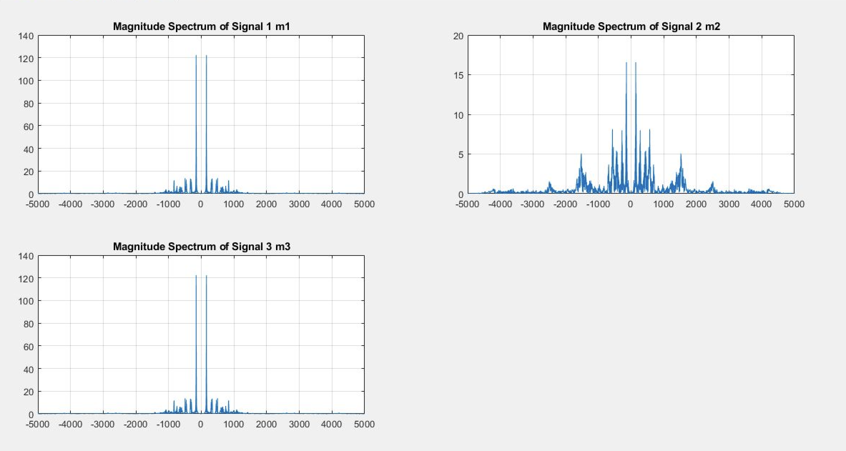

**Task 2:**

* Detailed analysis of our modulated signals in both time and frequency domain they are not multiplexed in this analysis.

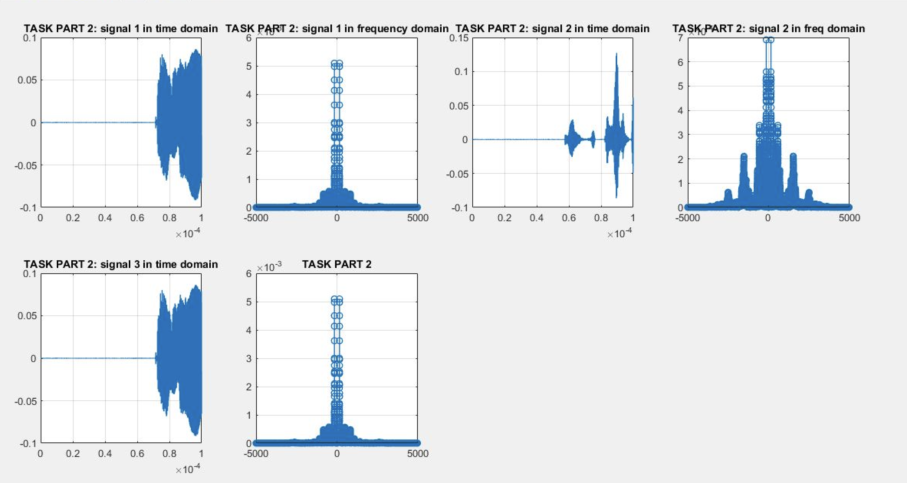

**Task 3:**

* Time domain analysis of our input audio signals with SSB FDM performed at transmitter end.

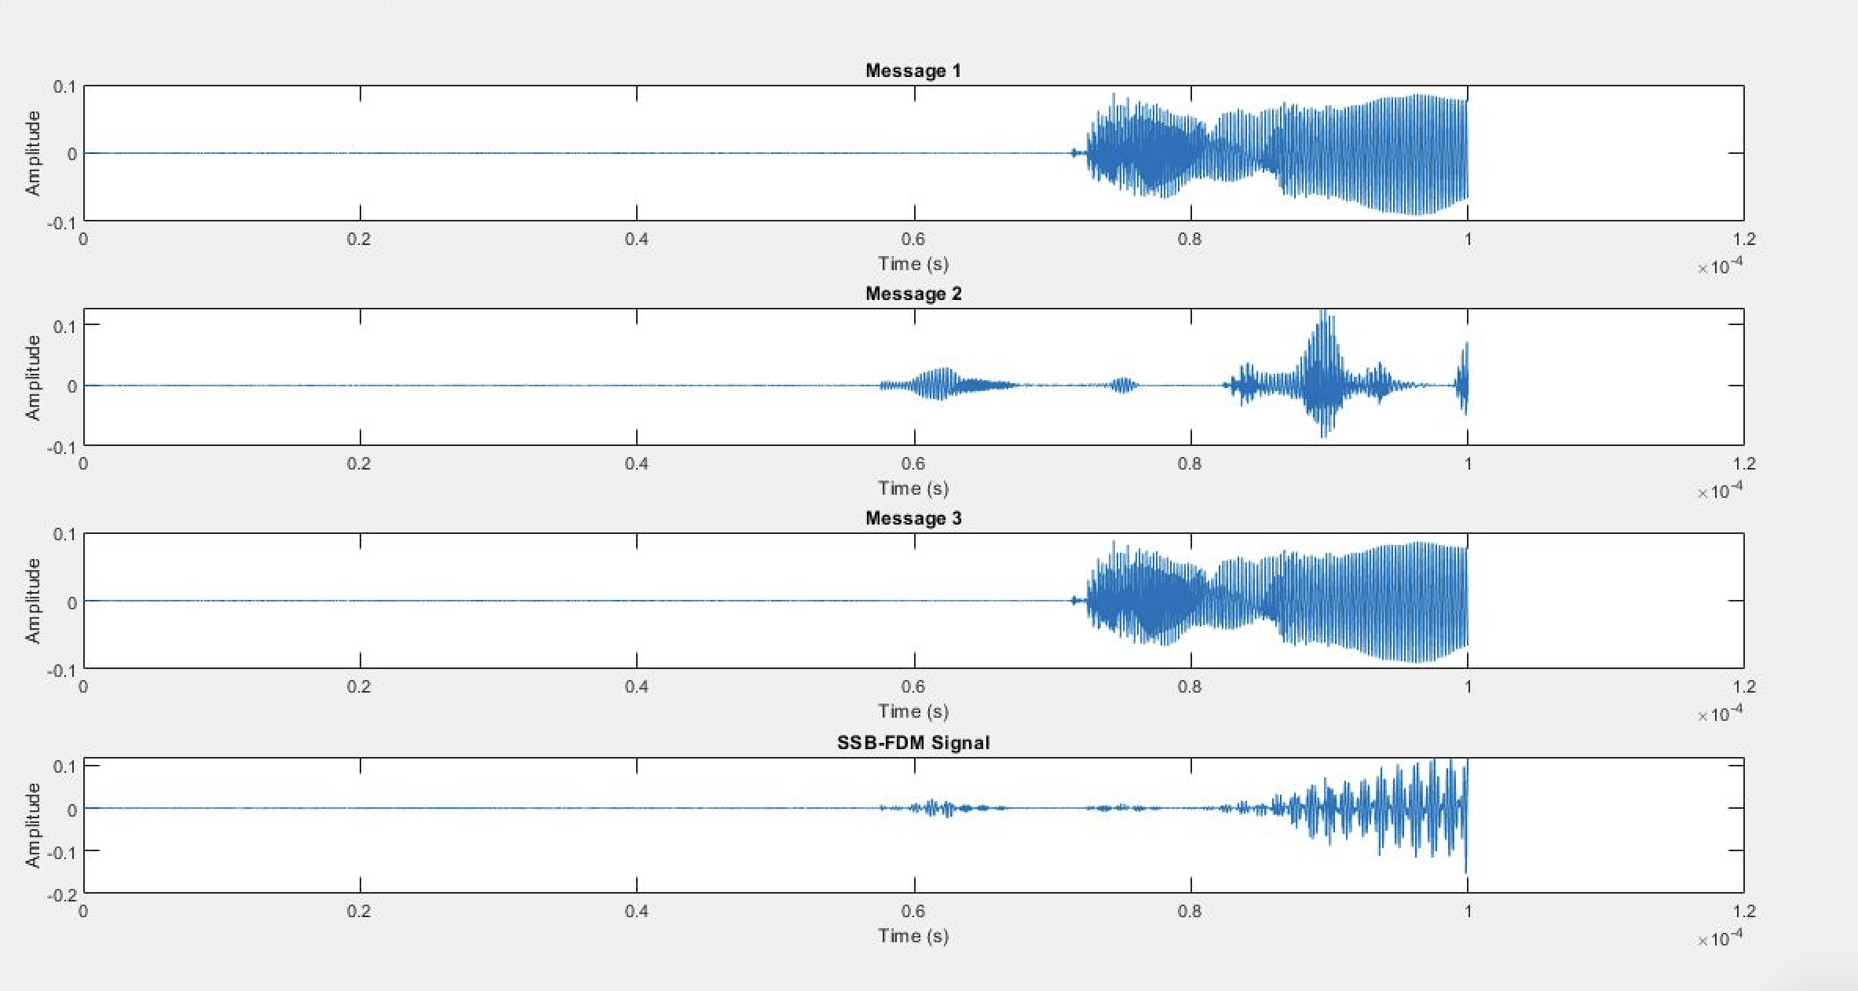

**Block Diagram of Transmitter:**

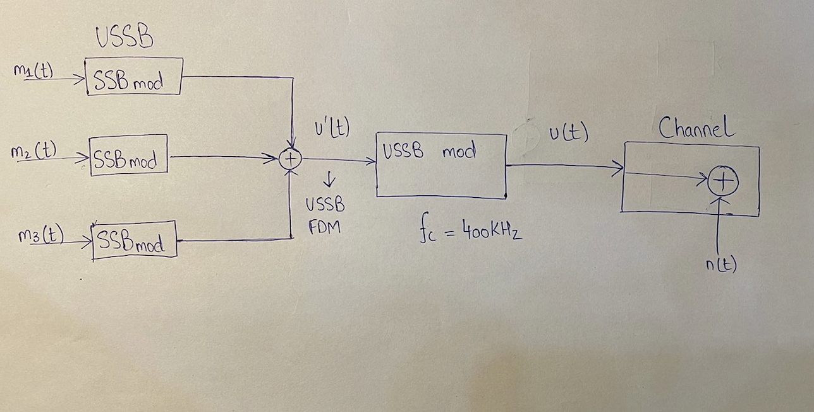

**Task 4:**

* During coding we wanted to test and analyze a typical correct Hilbert Transform of a signal before Task 4, so we tested on audio signal m1 over here:

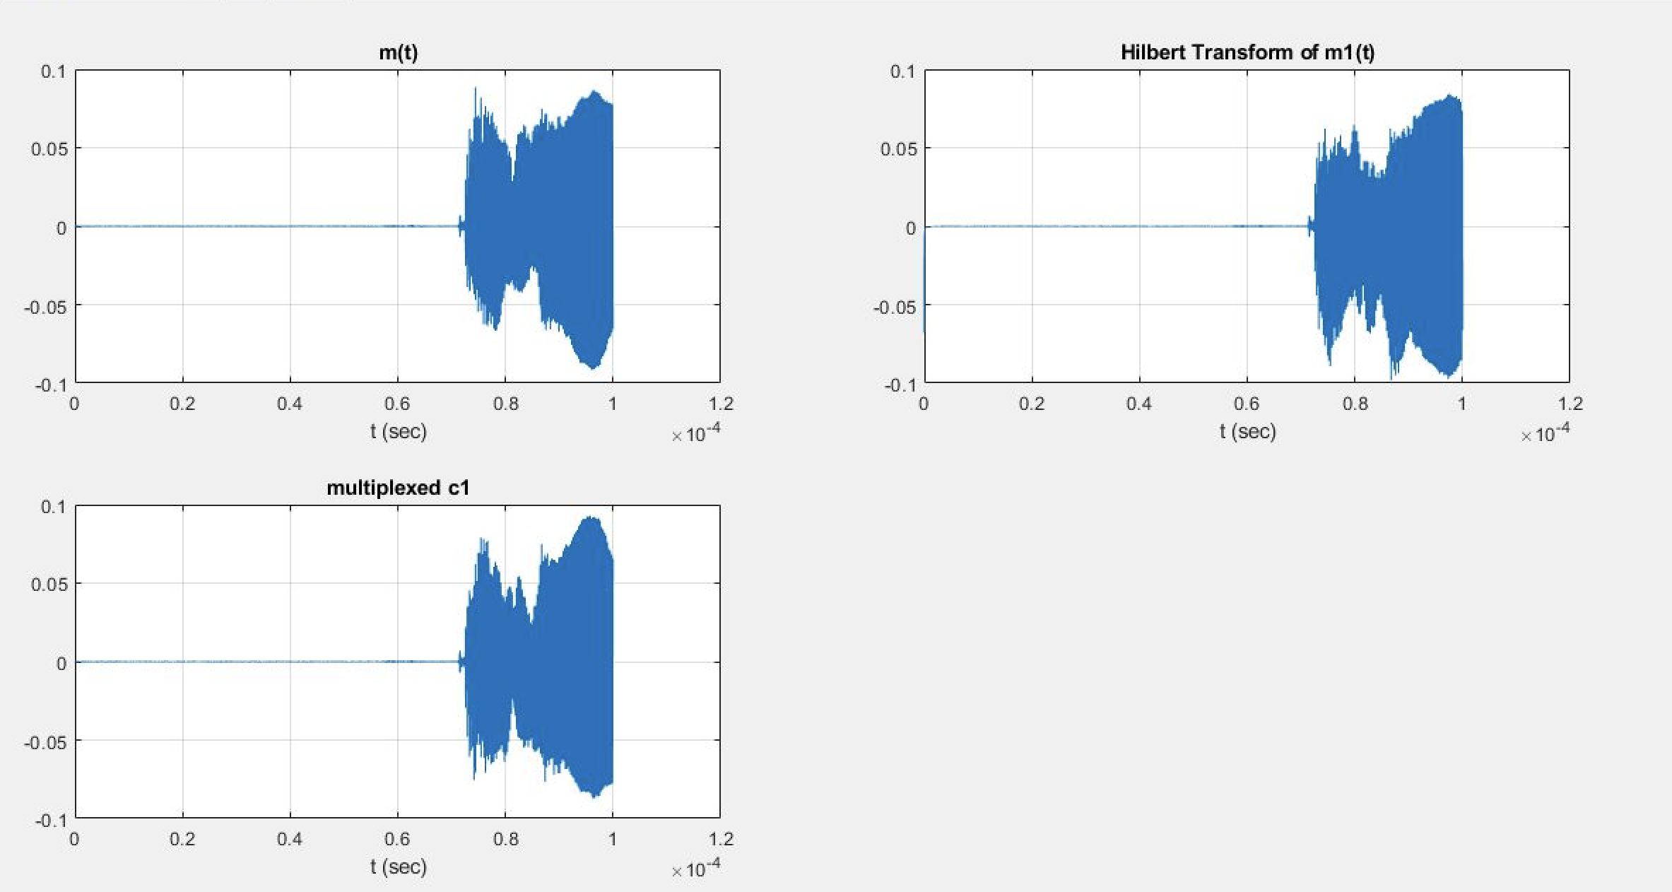

* Analyzing the effect of White Gaussian Noise on the received signal with a low SNR of 5.

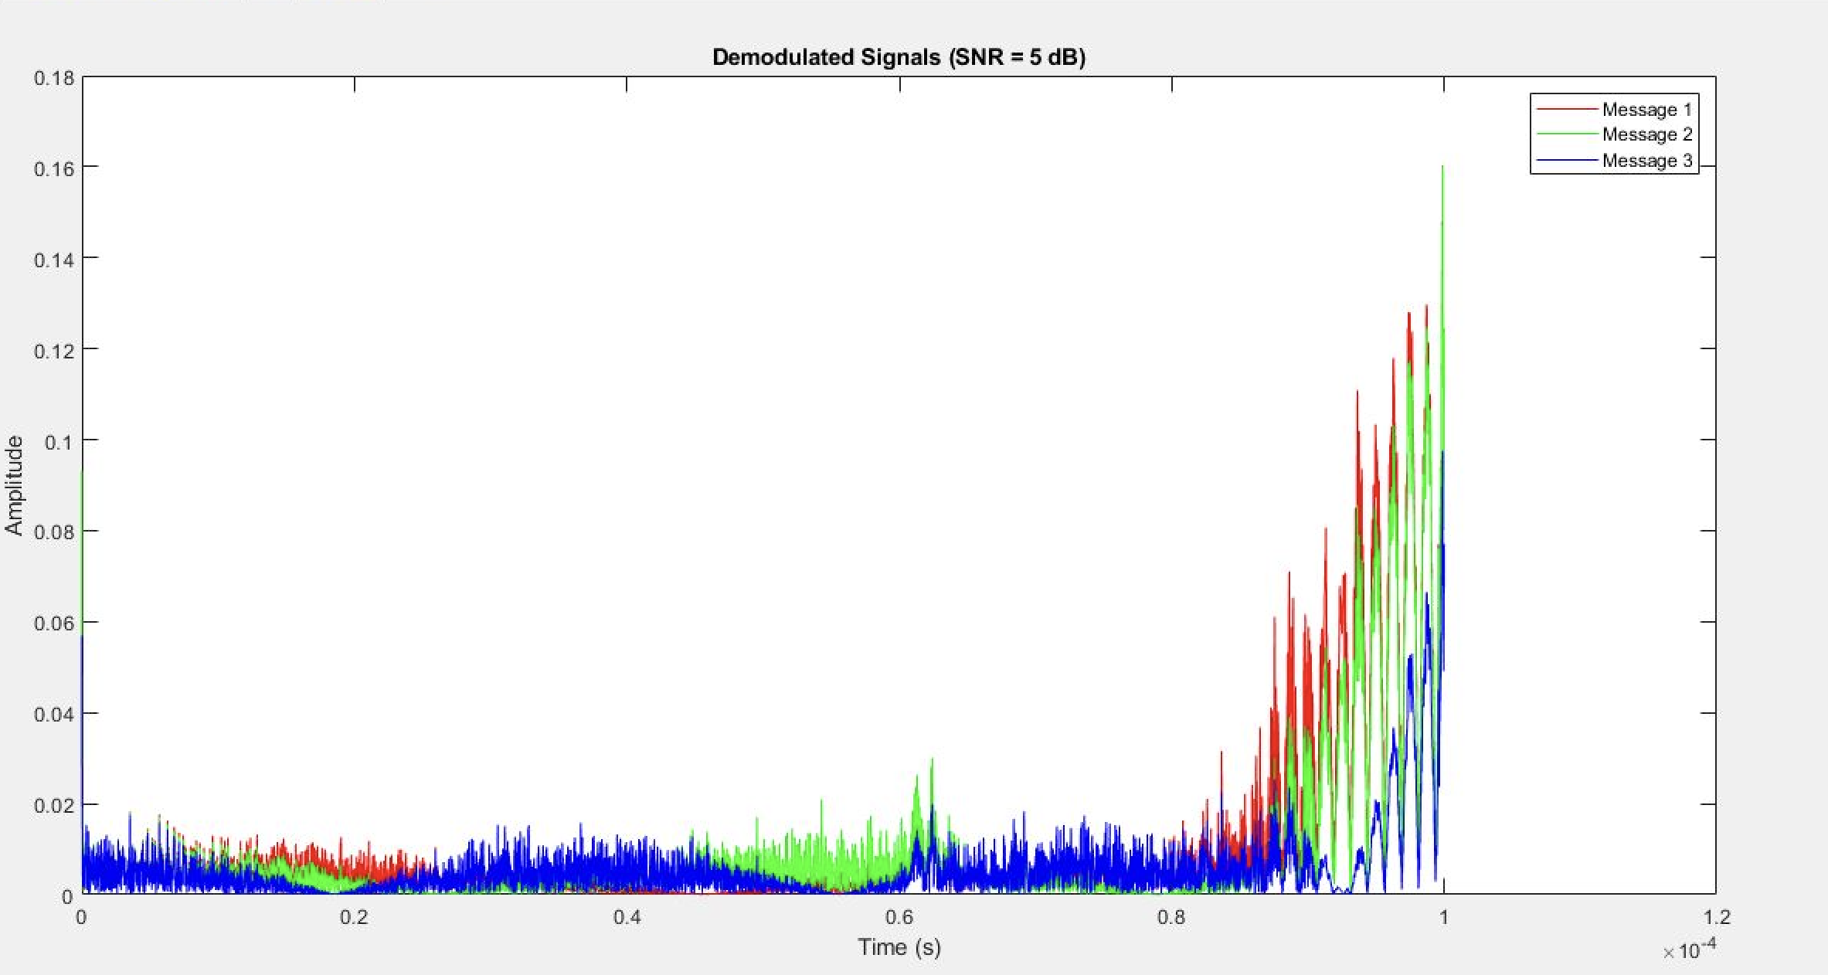

* We study the magnitude spectrum of each individual signal we obtained back from demultiplexing at this stage and compare it with our original m1 m2 and m3 audio signals to see how well our signals demodulated back to us at SNR 5 here.

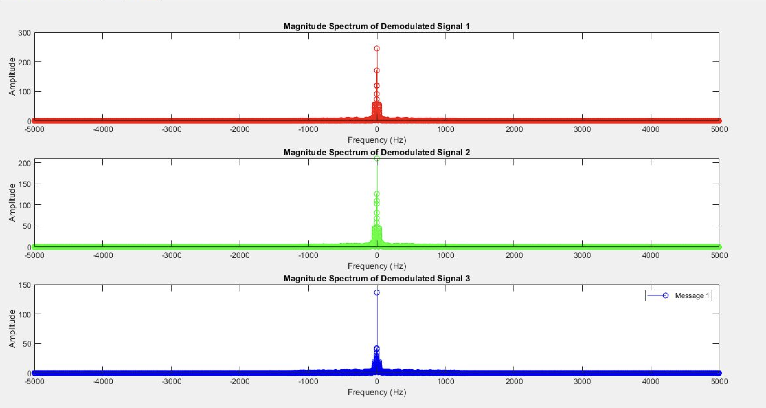

* Again, we analyze the effect of White Gaussian Noise on the received signal with an SNR of 10.

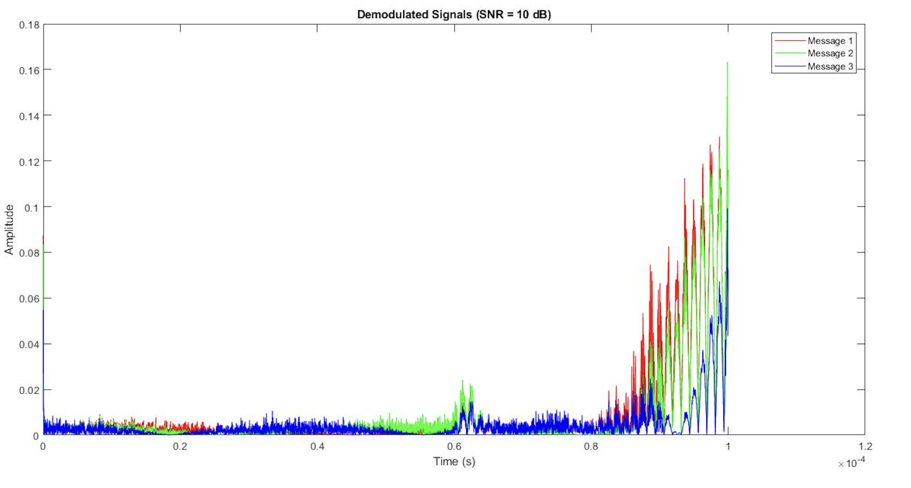

* We study the magnitude spectrum of each individual signal we obtained back from demultiplexing at this stage and compare it with our original m1 m2 and m3 audio signals to see how well our signals demodulated back to us at SNR 10.

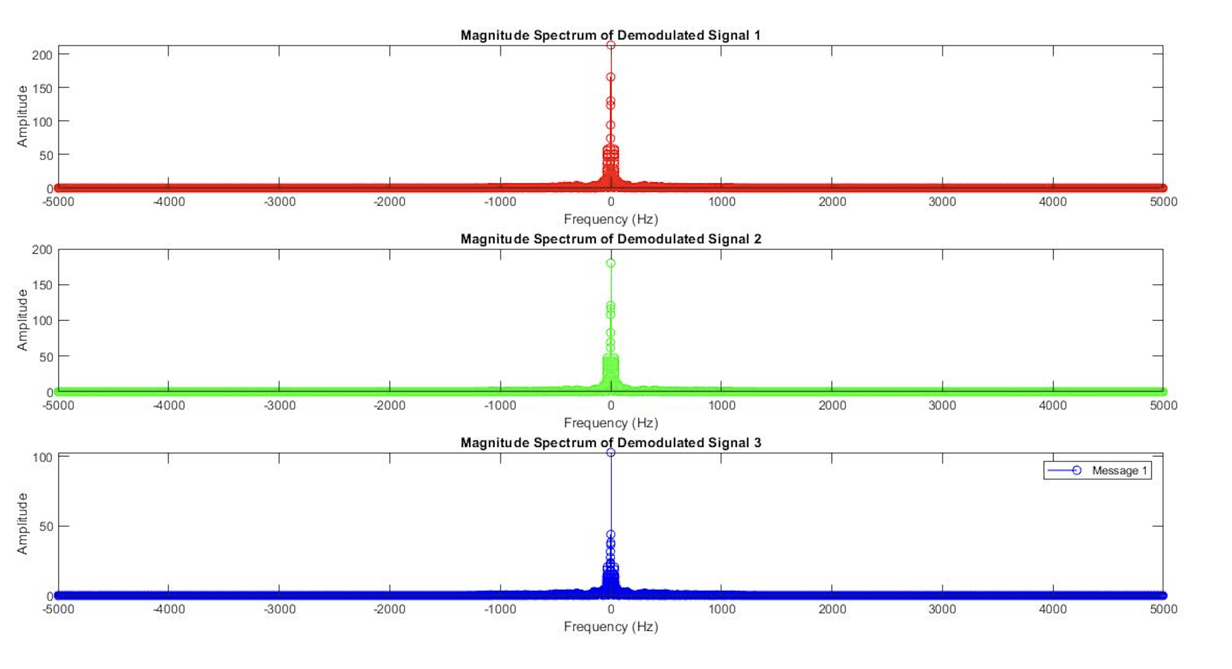

* Again, we analyze the effect of White Gaussian Noise on the received signal with max SNR of 20.

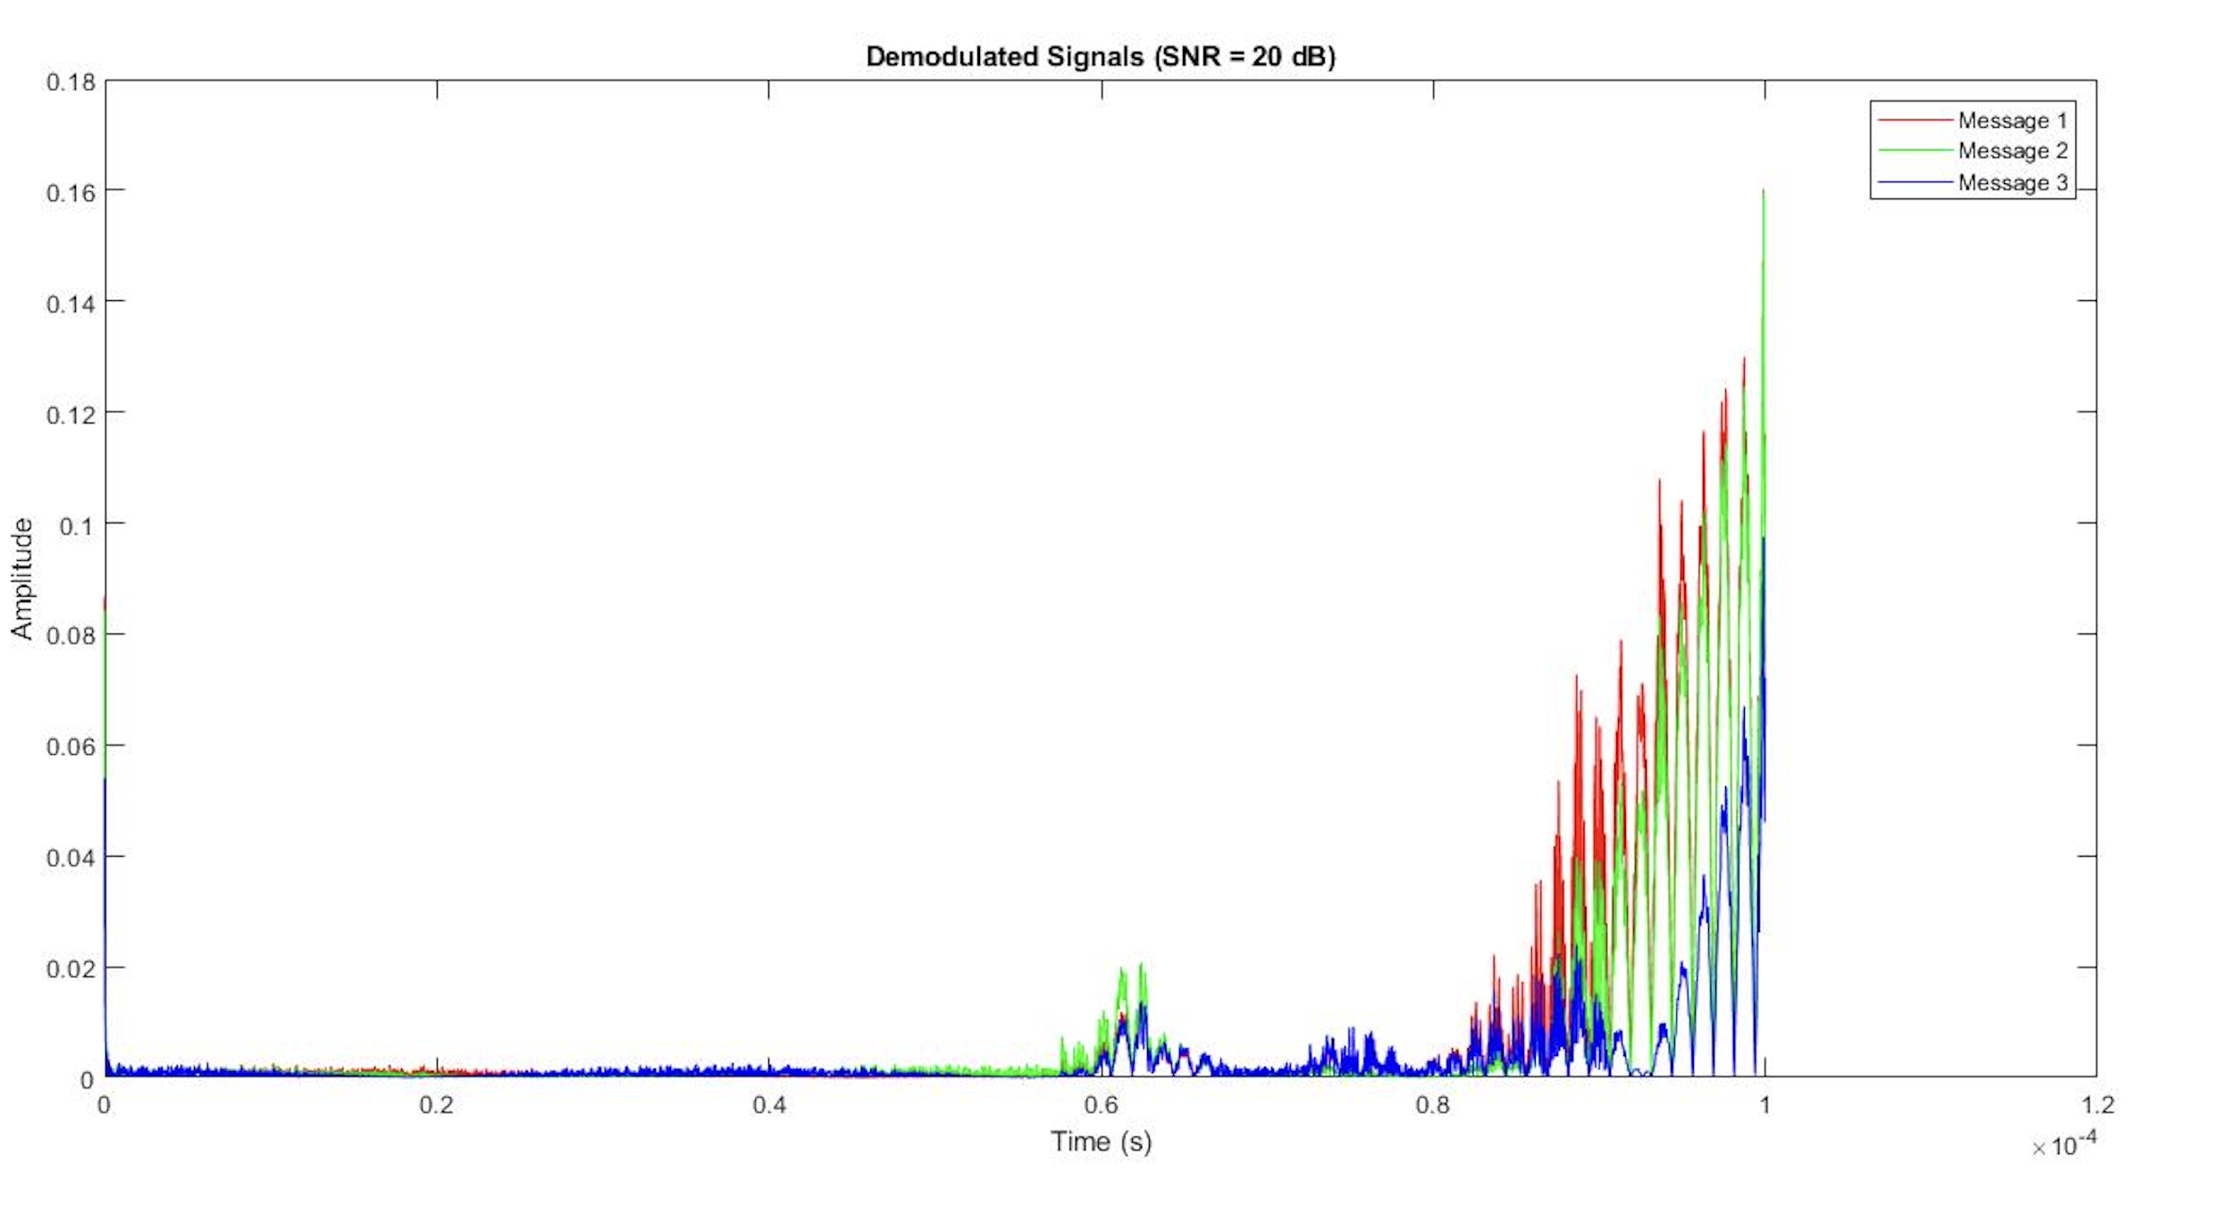

* Once more we look at the magnitude spectrum of each individual signal, we obtained back from demultiplexing at this stage and compare it with our original m1 m2 and m3 audio signals to see how well our signals demodulated back to us at SNR 20.

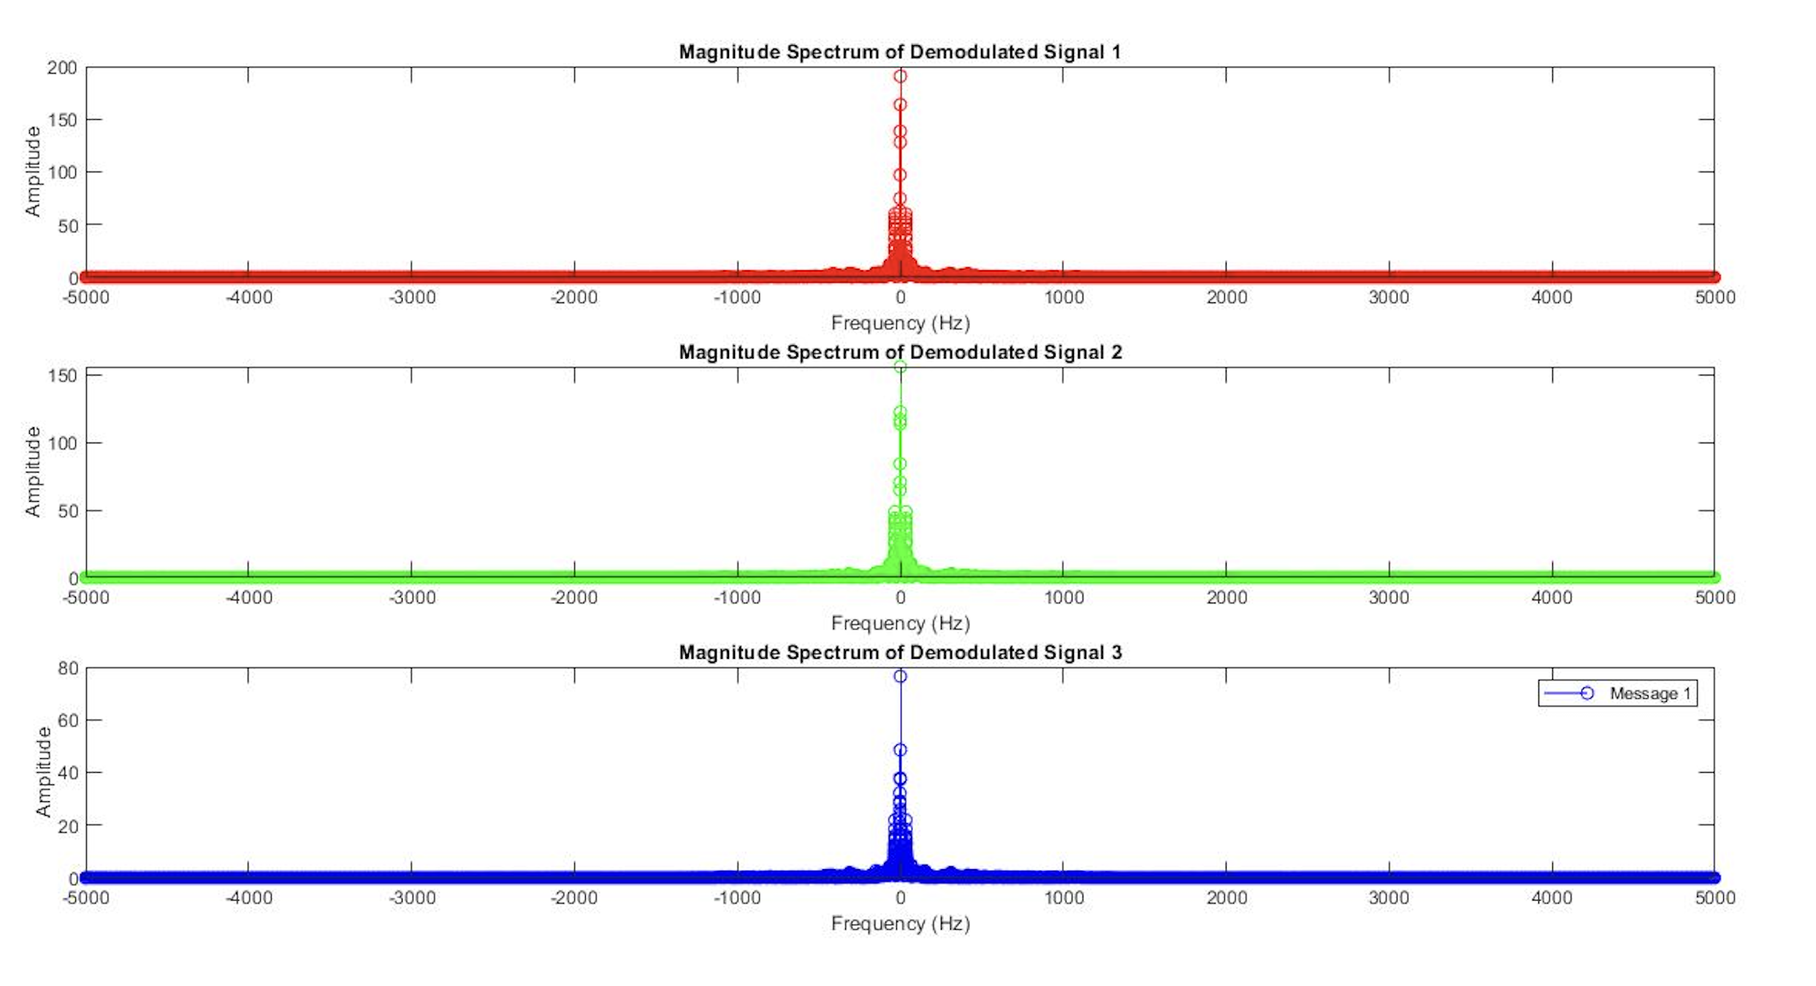

**Block Diagram of Receiver:**

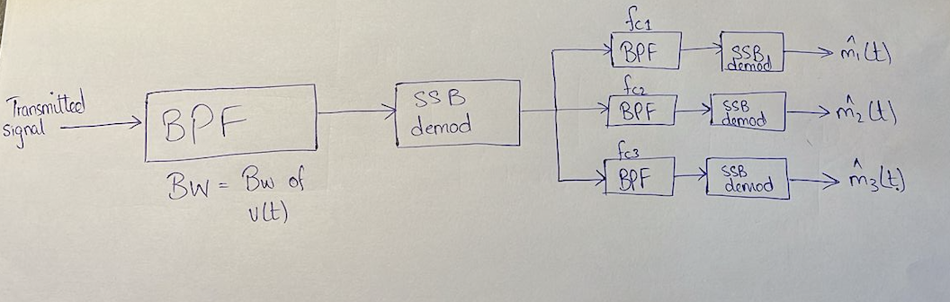

## **Conclusion**

The project demonstrates the end-to-end communication system, analyzing the effects of noise on the demodulated signals under varying SNR conditions. The code computes each demodulated signal's magnitude spectrum before and after demodulation. The effects of noise at various signal-to-noise ratio (SNR) levels on the demodulated signals are investigated via audio playback and visuals.